RAJALAKSHMI ENGINEERING COLLEGE
(An Autonomous Institution)
RAJALAKSHMI NAGAR, THANDALAM- 602 105



CS19P18 - DEEP LEARNING CONCEPTS
LABORATORY RECORD NOTEBOOK

NAME: G SHREYA MRIDULA
YEAR/SEMESTER: IV/VII BRANCH: CSE
REGISTER NO: 2116220701271 COLLEGE ROLL NO: 220701271 ACADEMIC YEAR: 2025 -2026


RAJALAKSHMI ENGINEERING COLLEGE
(An Autonomous Institution)
RAJALAKSHMI NAGAR, THANDALAM- 602 105

BONAFIDE CERTIFICATE

NAME: SHREYA MRIDULA G BRANCH/SECTION: CSE

ACADEMIC YEAR: 2025 -2026 SEMESTER: VII

REGISTER NO:
2116220701271

Certified that this is a Bonafide record of work done by the above student in the CS19P18 - DEEP LEARNING CONCEPTS
during the year 2025 - 2026

Signature of Faculty In-charge

Submitted for the Practical Examination Held on: ………………………………………...

Internal Examiner External Examiner

INDEX

EX.NO | DATE | NAME OF THE EXPERIMENT | PAGE NO | STAFF SIGN
1 | 20. 8.2025 | Create a neural network to recognize handwritten digits using MNIST dataset | 5
2 | 27. 8.2025 | Build a Convolutional Neural Network  with Keras/TensorFlow | 9
3 | 3.9.2025 | Image Classification on CIFAR-10  Dataset using CNN | 14
4 | 10.9.2025 | Transfer learning with CNN and  Visualization | 18
5 | 17.9.2025 | Build a Recurrent Neural Network using  Keras/Tensorflow | 23
6 | 24.9.2025 | Sentiment Classification of Text using  RNN | 27
7 | 29.9.2025 | Build autoencoders with keras/tensorflow | 30
8 | 06.10.2025 | Object detection with yolo3 | 34
9 | 29.09.2025 | Build GAN with Keras/TensorFlow | 39
10 | 08.10.2025 | Mini Project | 44

INSTALLATION AND CONFIGURATION OF TENSORFLOW

Aim:

To install and configure TensorFlow in anaconda environment in Windows 10.

Procedure:

- Download Anaconda Navigator and install.

- Open Anaconda prompt

- Create a new environment dlc with python 3.7 using the following command: conda create -n dlc python=3.7

- Activate newly created environment dlc using the following command: conda activate dlc

- In dlc prompt, install tensorflow using the following command: pip install tensorflow
- Next install Tensorflow-datasets using the following command: pip install tensorflow-datasets

- Install scikit-learn package using the following command: pip install scikit-learn

- Install pandas package using the following command: pip install pandas

- Lastly, install jupyter notebook pip install jupyter notebook

- Open jupyter notebook by typing the following in dlc prompt: jupyter notebook

- Click create new and then choose python 3 (ipykernel)

- Give the name to the file

- Type the code and click Run button to execute (eg. Type import tensorflow and then run)

EX NO: 1 CREATE A NEURAL NETWORK TO RECOGNIZE HANDWRITTEN DIGITS USING MNIST DATASET

Aim:

To build a handwritten digit’s recognition with MNIST dataset.

Procedure:

- Download and load the MNIST dataset.
- Perform analysis and preprocessing of the dataset.
- Build a simple neural network model using Keras/TensorFlow.
- Compile and fit the model.
- Perform prediction with the test dataset.
- Calculate performance metrics.

Code:
import numpy as np
import matplotlib.pyplot as plt import tensorflow as tf
from tensorflow.keras.datasets import mnist from tensorflow.keras.models import Sequential from tensorflow.keras.layers import Dense from tensorflow.keras.utils import to_categorical

feature_vector_length = 784
num_classes = 10

(X_train, Y_train), (X_test, Y_test) = mnist.load_data()

input_shape = (feature_vector_length) print(f'Feature shape: {input_shape}')

X_train = X_train.reshape(X_train.shape[0], feature_vector_length) X_test = X_test.reshape(X_test.shape[0], feature_vector_length) X_train = X_train.astype('float32') / 255
X_test = X_test.astype('float32') / 255
Y_train = to_categorical(Y_train, num_classes) Y_test = to_categorical(Y_test, num_classes)

model = Sequential()
model.add(Dense(350, input_shape=input_shape, activation='relu')) model.add(Dense(50, activation='relu')) model.add(Dense(num_classes, activation='softmax'))

model.compile(loss='categorical_crossentropy', optimizer='adam', metrics=['accuracy']) model.fit(X_train, Y_train, epochs=10, batch_size=250, verbose=1, validation_split=0.2)

test_results = model.evaluate(X_test, Y_test, verbose=1)
print(f'Test results - Loss: {test_results[0]} - Accuracy: {test_results[1]}')

predictions = model.predict(X_test[:5]) predicted_classes = np.argmax(predictions, axis=1) true_classes = np.argmax(Y_test[:5], axis=1)

for i in range(5):
plt.imshow(X_test[i].reshape(28, 28), cmap='gray')
plt.title(f"Sample {i+1} - Predicted: {predicted_classes[i]}, Actual: {true_classes[i]}") plt.axis('off')
plt.show()

Output:

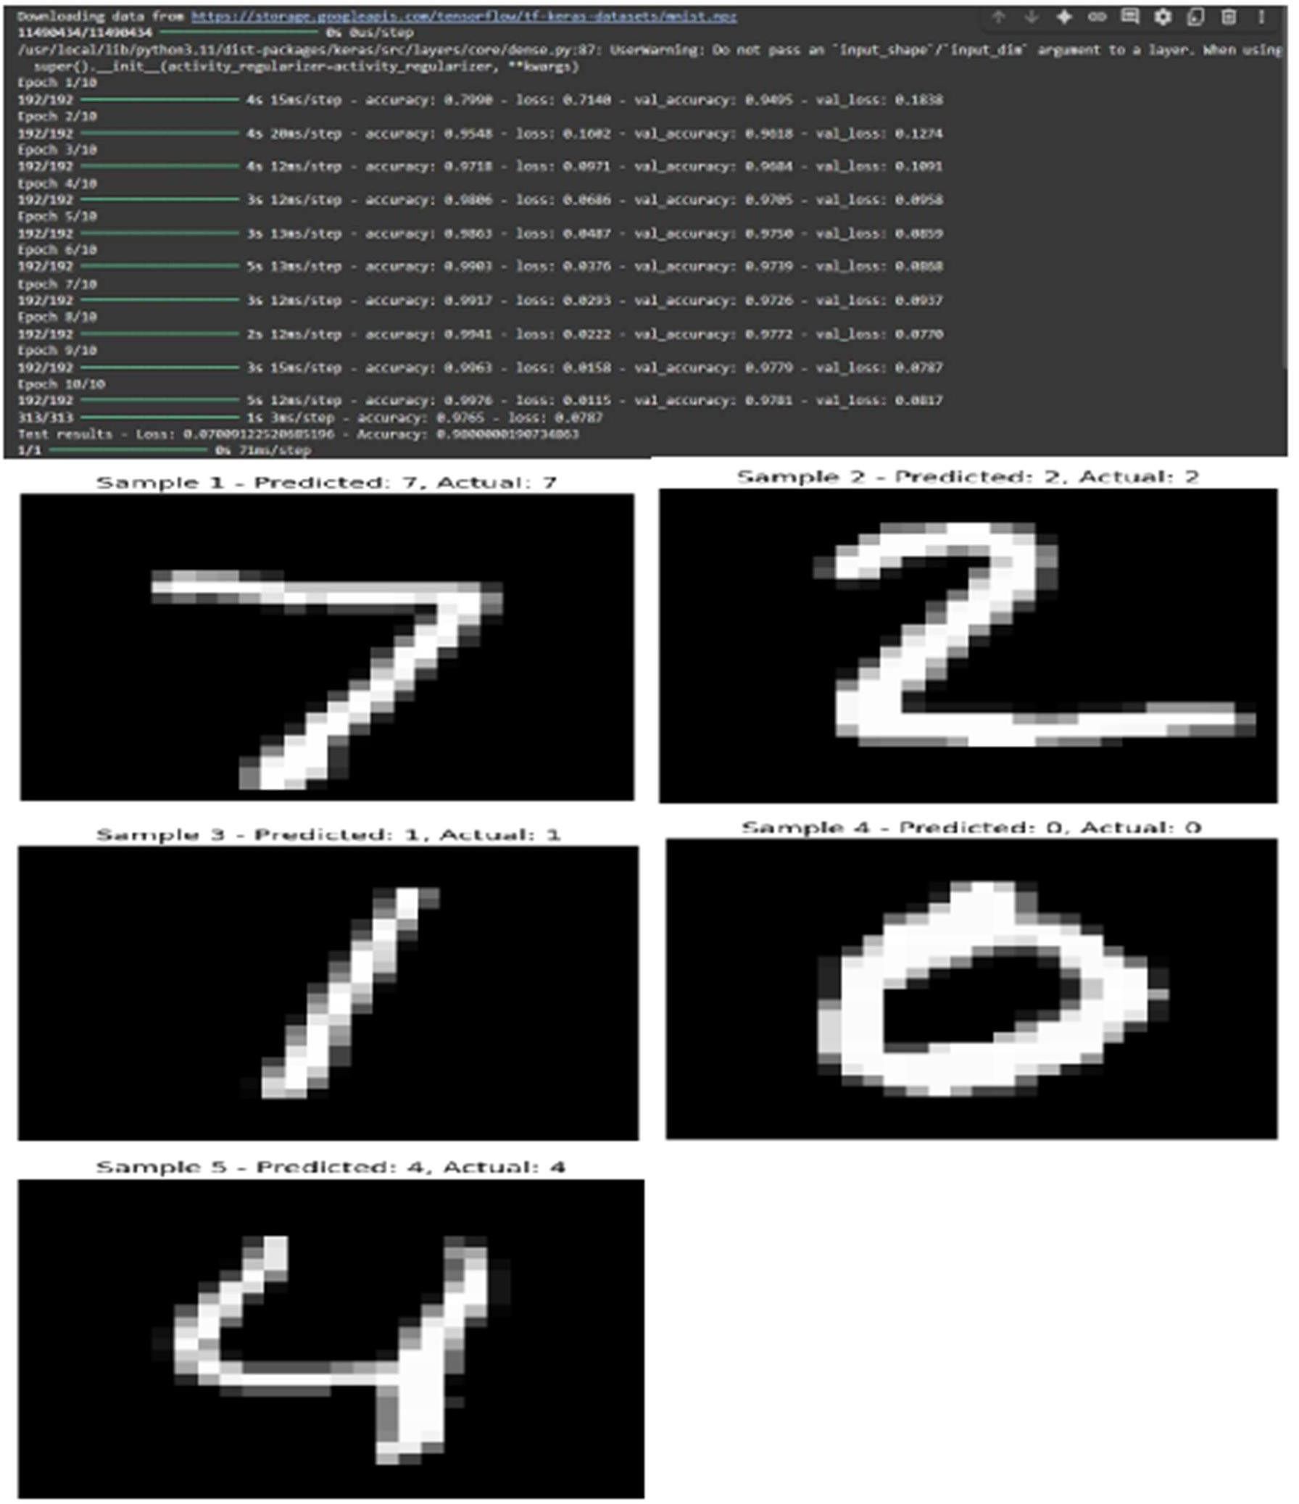

Result:

A handwritten digit’s recognition with MNIST dataset is built and the output is verified.

EX NO:2 BUILD A CONVOLUTIONAL NEURAL NETWORK
USING KERAS/TENSORFLOW

Aim:
To implement a Convolutional Neural Network (CNN) using Keras/TensorFlow to recognize and classify handwritten digits from the MNIST dataset with high accuracy.

Procedure:
- Import required libraries (TensorFlow/Keras, NumPy, etc.).
- Load the MNIST dataset from Keras.
- Normalize and reshape the image data.
- Convert labels to one-hot encoded vectors.
- Build a CNN model with Conv2D, MaxPooling, Flatten, and Dense layers.
- Compile the model using categorical crossentropy and Adam optimizer.
- Train the model on training data.
- Evaluate the model on test data.
- Display accuracy and predictions.

Code:
import tensorflow as tf
from tensorflow.keras.models import Sequential
from tensorflow.keras.layers import Conv2D, MaxPooling2D, Flatten, Dense, Dropout from tensorflow.keras.datasets import mnist
import matplotlib.pyplot as plt import numpy as np

(train_images, train_labels), (test_images, test_labels) = mnist.load_data() train_images = train_images / 255.0
test_images = test_images / 255.0
train_images = train_images.reshape(-1, 28, 28, 1)
test_images = test_images.reshape(-1, 28, 28, 1) model = Sequential([
Conv2D(32, (3, 3), activation='relu', input_shape=(28, 28, 1)),
MaxPooling2D((2, 2)),
Conv2D(64, (3, 3), activation='relu'),
MaxPooling2D((2, 2)), Flatten(),
Dense(64, activation='relu'), Dropout(0.5),
Dense(10, activation='softmax')
])

model.compile(optimizer='adam', loss='sparse_categorical_crossentropy', metrics=['accuracy'])

history = model.fit(train_images, train_labels, epochs=5,
batch_size=64, validation_split=0.2)

test_loss, test_acc = model.evaluate(test_images, test_labels) print(f"\n Test accuracy: {test_acc:.4f}")
print(f" Test loss: {test_loss:.4f}")

plt.figure(figsize=(12, 5))
plt.subplot(1, 2, 1)
plt.plot(history.history['accuracy'], label='Train Accuracy', marker='o') plt.plot(history.history['val_accuracy'], label='Validation Accuracy', marker='o') plt.title('Training and Validation Accuracy')
plt.xlabel('Epoch') plt.ylabel('Accuracy') plt.legend() plt.grid(True)

plt.subplot(1, 2, 2)
plt.plot(history.history['loss'], label='Train Loss', marker='o') plt.plot(history.history['val_loss'], label='Validation Loss', marker='o') plt.title('Training and Validation Loss')
plt.xlabel('Epoch') plt.ylabel('Loss') plt.legend() plt.grid(True) plt.tight_layout() plt.show()

predictions = model.predict(test_images) predicted_labels = np.argmax(predictions, axis=1)

num_samples = 10
plt.figure(figsize=(15, 4))

for i in range(num_samples):
plt.subplot(1, num_samples, i + 1) plt.imshow(test_images[i].reshape(28, 28), cmap='gray') plt.title(f"Pred: {predicted_labels[i]}\nTrue: {test_labels[i]}") plt.axis('off')
plt.suptitle("Sample Predictions on Test Images", fontsize=16) plt.show()

Output:

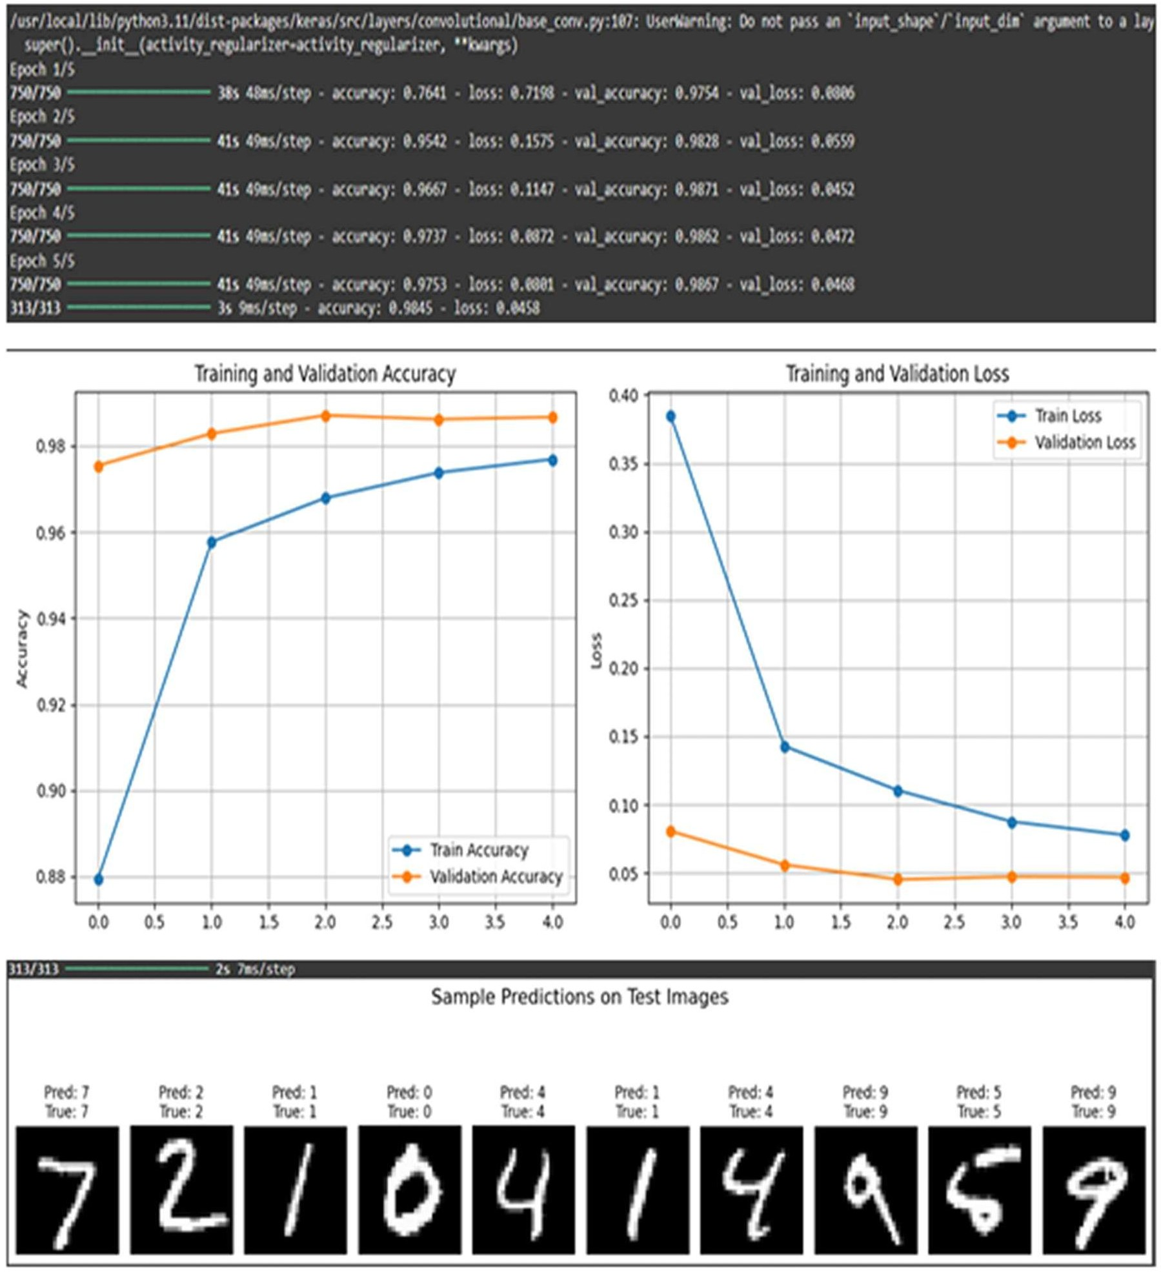

Result:

A CNN using Keras/TensorFlow to recognize and classify handwritten digits from the MNIST dataset with high accuracy is built and the output is verified.

EX NO: 3 IMAGE CLASSIFICATION ON CIFAR-10 DATASET USING CNN

Aim:
To build a Convolutional Neural Network (CNN) model for classifying images from the CIFAR-10 dataset into one of the ten categories such as airplanes, cars, birds, cats, etc.

Procedure:

- Download and load the CIFAR-10 dataset using Keras/TensorFlow.
- Visualize and analyze sample images from the dataset. 3, Preprocess the data:
  - Normalize the pixel values (divide by 255)
  - Convert class labels to one-hot encoded format
- Build a CNN model using Keras/TensorFlow:
  - Include convolutional, pooling, flatten, and dense layers.
- Compile the model with suitable loss function and optimizer.
- Train the model using training data and validate using test data.
- Evaluate the model using accuracy and loss on test dataset.
- Perform predictions on new/unseen CIFAR-10 images.
9 Visualize prediction results with sample images and predicted labels.

Code:
import tensorflow as tf import numpy as np
import matplotlib.pyplot as plt

(x_train, y_train), (x_test, y_test) = tf.keras.datasets.cifar10.load_data()

x_train = x_train.astype('float32') / 255.0 x_test = x_test.astype('float32') / 255.0

y_train = tf.keras.utils.to_categorical(y_train, 10) y_test = tf.keras.utils.to_categorical(y_test, 10)

model = tf.keras.Sequential()
model.add(tf.keras.layers.Conv2D(32, (3,3), activation='relu', input_shape=(32,32,3))) model.add(tf.keras.layers.MaxPooling2D((2,2))) model.add(tf.keras.layers.Conv2D(64, (3,3), activation='relu')) model.add(tf.keras.layers.MaxPooling2D((2,2))) model.add(tf.keras.layers.Conv2D(64, (3,3), activation='relu')) model.add(tf.keras.layers.Flatten())
model.add(tf.keras.layers.Dense(64, activation='relu')) model.add(tf.keras.layers.Dense(10, activation='softmax'))

model.compile(optimizer='adam', loss='categorical_crossentropy', metrics=['accuracy'])

model.fit(x_train, y_train, epochs=10, batch_size=64, validation_split=0.2)

class_names = ['airplane', 'automobile', 'bird', 'cat', 'deer', 'dog', 'frog', 'horse', 'ship', 'truck']

index = int(input("Enter an index (0 to 9999) for test image: "))

if index < 0 or index >= len(x_test):

print("Invalid index. Using index 0 by default.") index = 0

test_image = x_test[index]
true_label = np.argmax(y_test[index])

prediction = model.predict(np.expand_dims(test_image, axis=0)) predicted_label = np.argmax(prediction)

plt.figure(figsize=(4, 4))
resized_image = tf.image.resize(test_image, [128, 128]) plt.imshow(resized_image)
plt.axis('off')
plt.title(f"Predicted: {class_names[predicted_label]}\nActual: {class_names[true_label]}") plt.show()

Output:

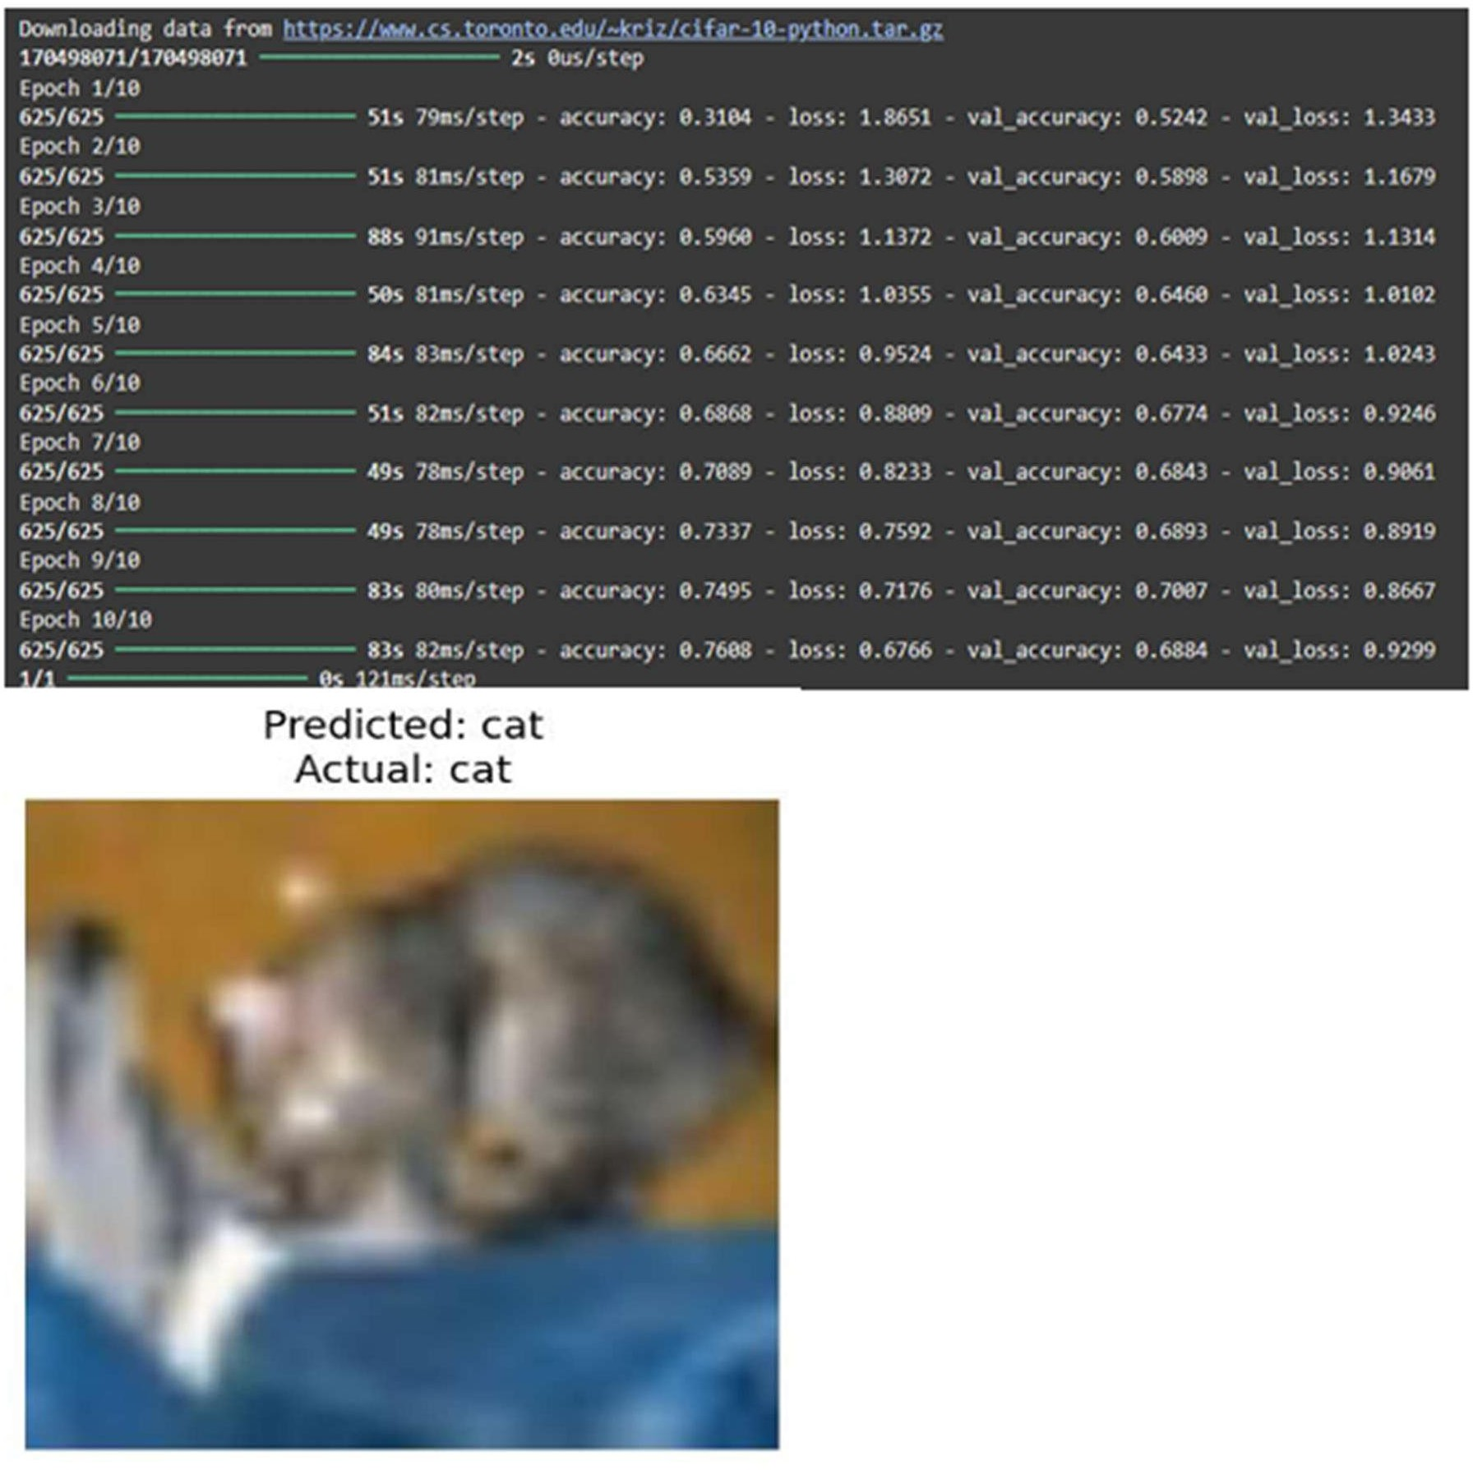

Result:

A Convolutional Neural Network (CNN) model for classifying images from the
CIFAR-10 dataset into one of the ten categories such as airplanes, cars, birds, cats, etc. is successfully built and the output is verified.

Ex No: 4 TRANSFER LEARNING WITH CNN AND VISUALIZATION

Aim:
To build a convolutional neural network with transfer learning and perform visualization

Procedure:

- Download and load the dataset.
- Perform analysis and preprocessing of the dataset.
- Build a simple neural network model using Keras/TensorFlow.
- Compile and fit the model.
- Perform prediction with the test dataset.
- Calculate performance metrics.

conda install -c conda-forge python-graphviz -y import tensorflow as tf
from tensorflow.keras.applications import VGG16 from tensorflow.keras.models import Sequential
from tensorflow.keras.layers import Dense, Flatten, Dropout from tensorflow.keras.optimizers import Adam
from tensorflow.keras.datasets import cifar10 from tensorflow.keras.utils import plot_model import matplotlib.pyplot as plt
import numpy as np
(x_train, y_train), (x_test, y_test) = cifar10.load_data() x_train = x_train / 255.0
x_test = x_test / 255.0
vgg_base = VGG16(weights='imagenet', include_top=False, input_shape=(32, 32, 3))

for layer in vgg_base.layers:
layer.trainable = False

model = Sequential() model.add(vgg_base) model.add(Flatten()) model.add(Dense(512, activation='relu')) model.add(Dropout(0.5)) model.add(Dense(10, activation='softmax'))
model.compile(optimizer=Adam(learning_rate=0.0001), loss='sparse_categorical_crossentropy', metrics=['accuracy'])

plot_model(model, to_file='cnn.png', show_shapes=True, show_layer_names=True, dpi=300)

plt.figure(figsize=(20, 20)) img = plt.imread('cnn.png') plt.imshow(img) plt.axis('off')
plt.show()

history = model.fit(x_train, y_train, epochs=10, batch_size=32, validation_split=0.2)

test_loss, test_acc = model.evaluate(x_test, y_test) print(f'Test Loss: {test_loss:.4f}')
print(f'Test Accuracy: {test_acc * 100:.2f}%') plt.figure(figsize=(12, 5))

plt.subplot(1, 2, 1)

plt.plot(history.history['accuracy'], label='Train Accuracy') plt.plot(history.history['val_accuracy'], label='Validation Accuracy') plt.title('Model Accuracy')
plt.xlabel('Epoch')

plt.ylabel('Accuracy') plt.legend()

plt.subplot(1, 2, 2) plt.plot(history.history['loss'], label='Train Loss')
plt.plot(history.history['val_loss'], label='Validation Loss') plt.title('Model Loss')
plt.xlabel('Epoch') plt.ylabel('Loss') plt.legend()

plt.tight_layout() plt.show()

class_names = ['airplane', 'automobile', 'bird', 'cat', 'deer', 'dog', 'frog', 'horse', 'ship', 'truck']

sample = x_test[0].reshape(1, 32, 32, 3) prediction = model.predict(sample)
predicted_class = class_names[np.argmax(prediction)]

plt.imshow(x_test[0]) plt.title(f"Predicted: {predicted_class}") plt.axis('off')
plt.show()

Output:

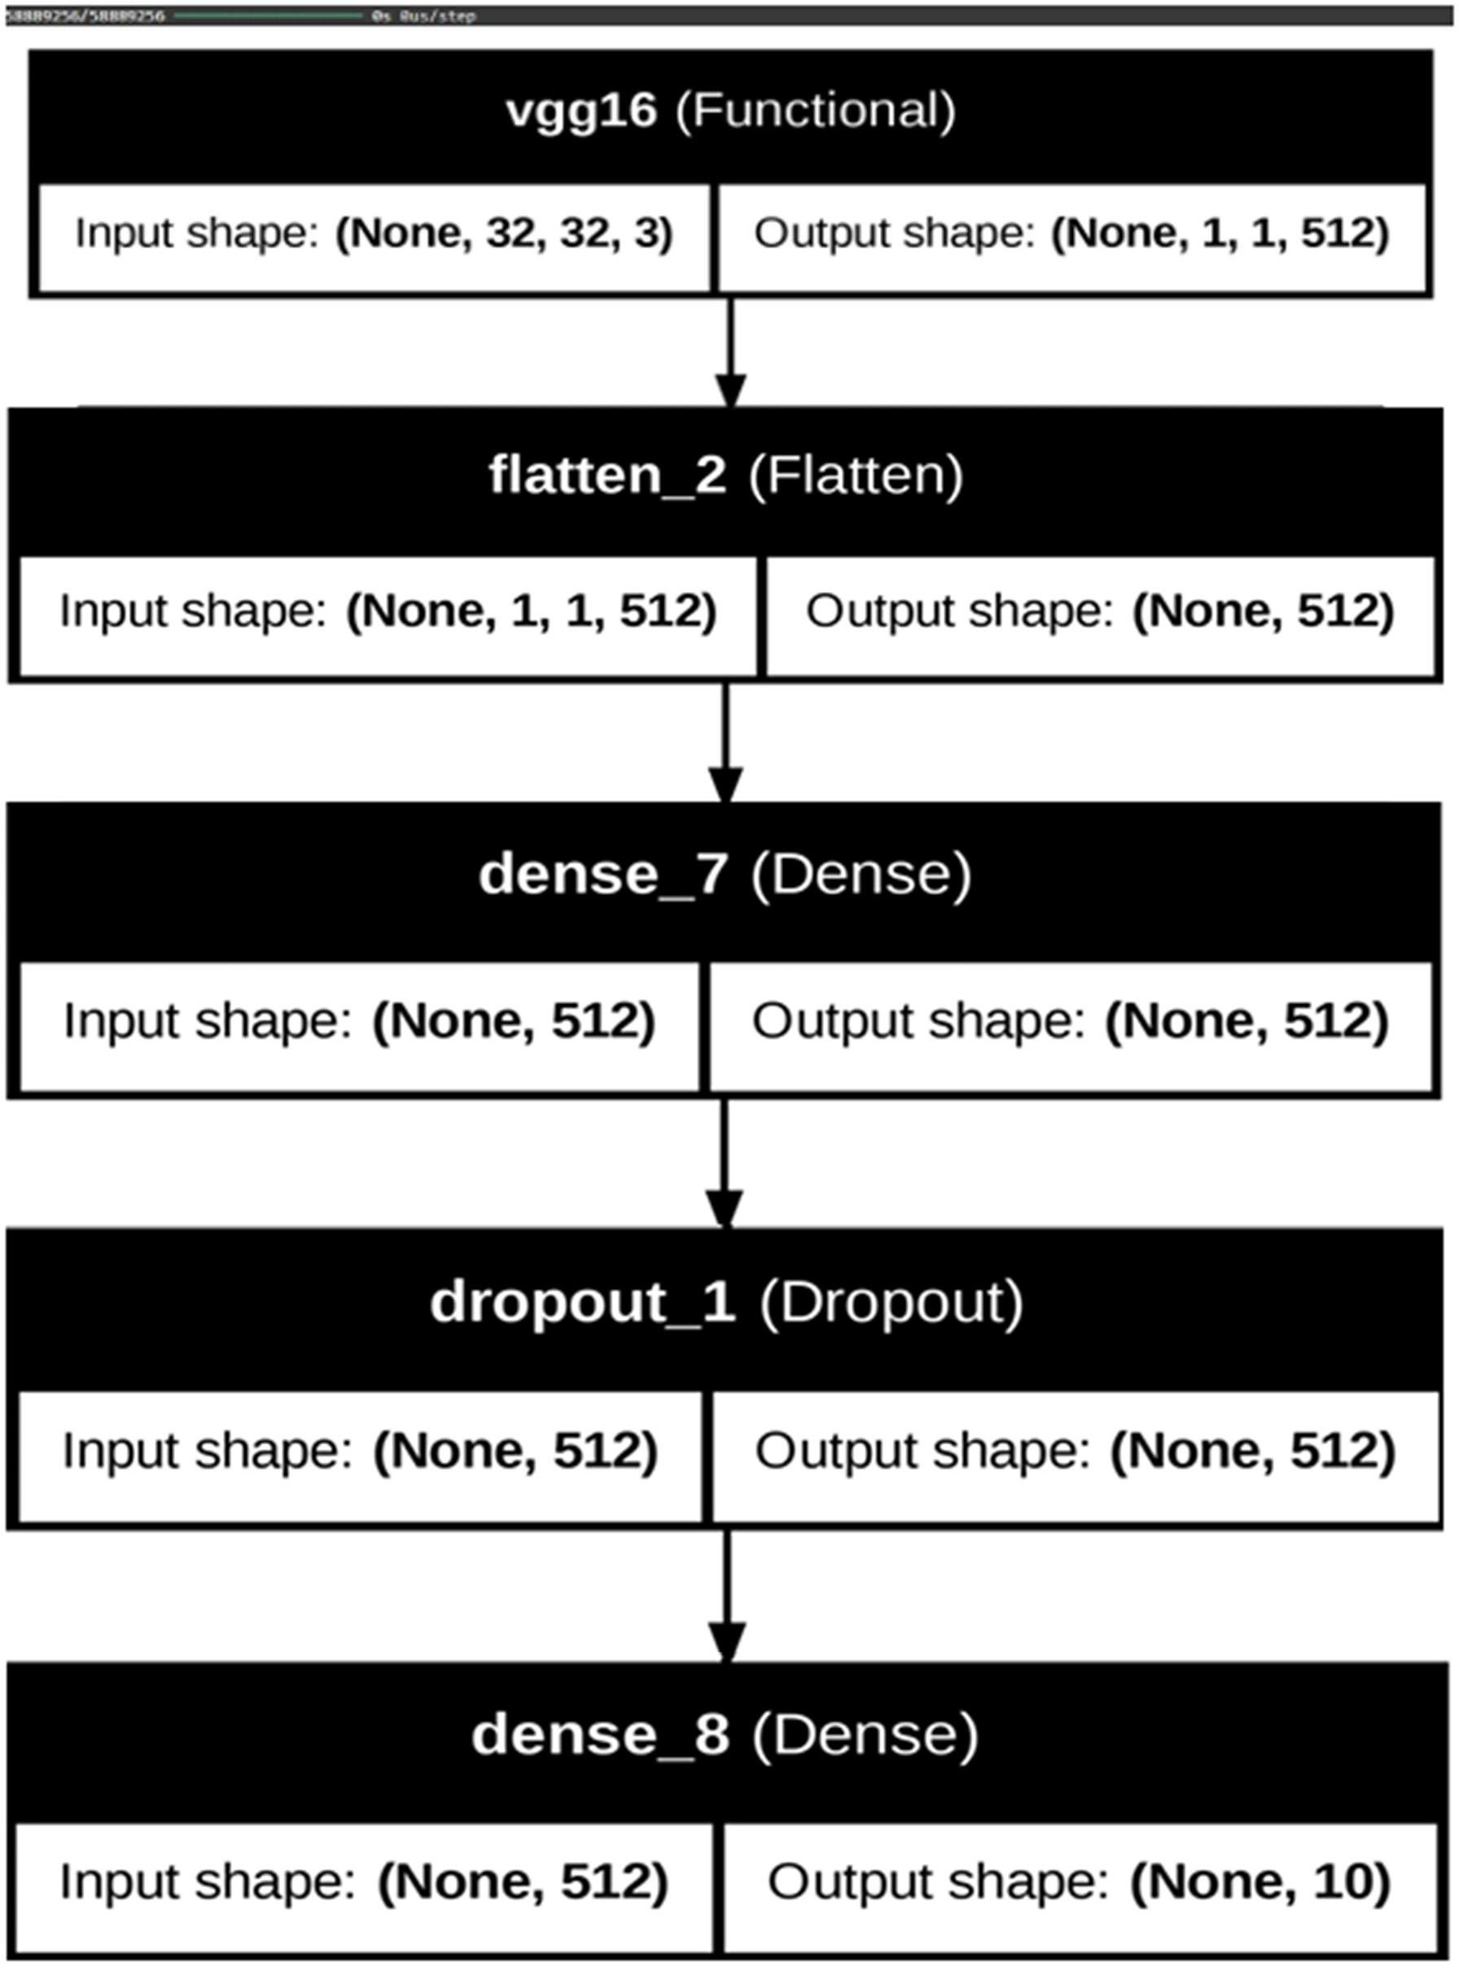

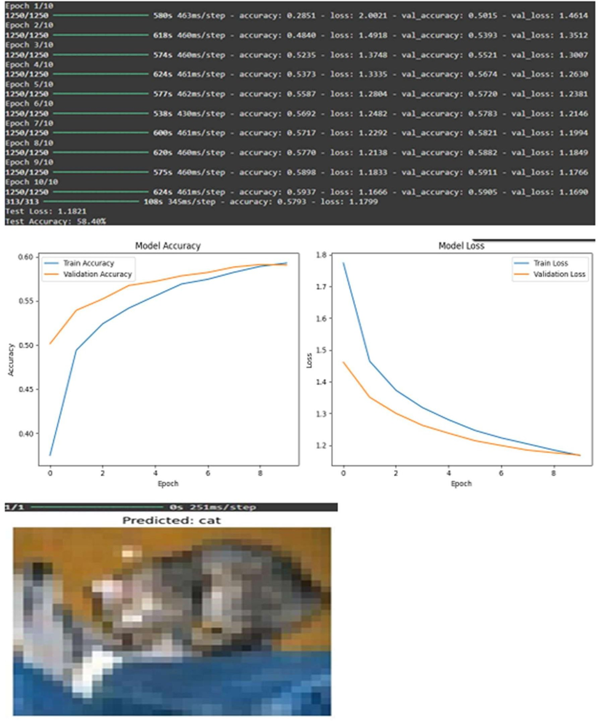

Result:

A CNN with transfer learning and perform visualization is built and the output is verified.

EX NO: 5 BUILD A RECURRENT NEURAL NETWORK (RNN) USING
KERAS/TENSORFLOW

Aim:
To build a recurrent neural network with Keras/TensorFlow.

Procedure:

- Download and load the dataset.
- Perform analysis and preprocessing of the dataset.
- Build a simple neural network model using Keras/TensorFlow.
- Compile and fit the model.
- Perform prediction with the test dataset.
- Calculate performance metrics.

import numpy as np import tensorflow as tf
from tensorflow.keras.models import Sequential
from tensorflow.keras.layers import SimpleRNN, Dense from sklearn.metrics import r2_score np.random.seed(0)
seq_length = 10
num_samples = 1000

X = np.random.randn(num_samples, seq_length, 1)

y = X.sum(axis=1) + 0.1 * np.random.randn(num_samples, 1)

split_ratio = 0.8
split_index = int(split_ratio * num_samples)

X_train, X_test = X[:split_index], X[split_index:] y_train, y_test = y[:split_index], y[split_index:]

model = Sequential()
model.add(SimpleRNN(units=50, activation='relu', input_shape=(seq_length, 1))) model.add(Dense(units=1))

model.compile(optimizer='adam', loss='mean_squared_error') model.summary()

batch_size = 30
epochs = 50 # Reduced epochs for quick demonstration history = model.fit(
X_train, y_train, batch_size=batch_size,

epochs=epochs, validation_split=0.2
)
test_loss = model.evaluate(X_test, y_test) print(f'Test Loss: {test_loss:.4f}')

y_pred = model.predict(X_test) r2 = r2_score(y_test, y_pred)
print(f'Test Accuracy (R^2): {r2:.4f}')

new_data = np.random.randn(5, seq_length, 1) predictions = model.predict(new_data) print("Predictions for new data:") print(predictions)

Output:
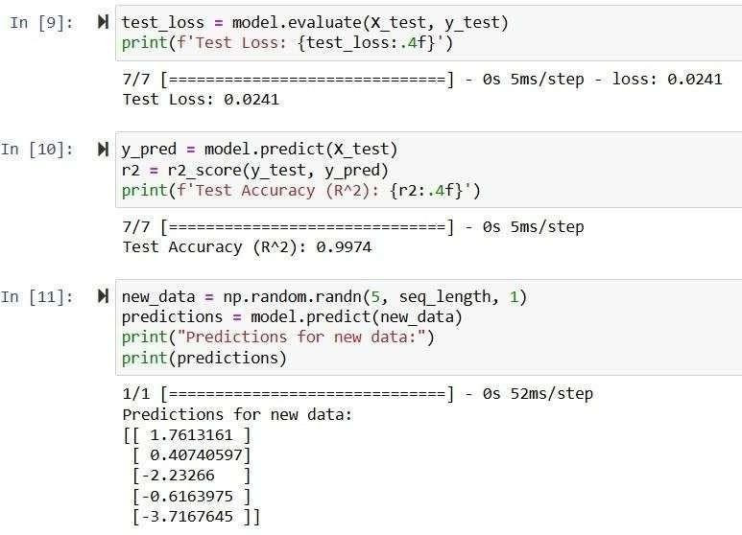

Result:

A recurrent neural network with Keras/TensorFlow is successfully built and the output is verified.

EX NO: 6 SENTIMENT CLASSIFICATION OF TEXT USING RNN

Aim:
To implement a Recurrent Neural Network (RNN) using Keras/TensorFlow for classifying
the sentiment of text data (e.g., movie reviews) as positive or negative.

Procedure:

- Import necessary libraries.

- Load and preprocess the text dataset (e.g., IMDb).

- Pad sequences and prepare labels.

- Build an RNN model with Embedding and SimpleRNN layers.

- Compile the model with loss and optimizer.

- Train the model on training data.

- Evaluate the model on test data.

- Predict sentiment for new inputs

import numpy as np
from tensorflow.keras.datasets import imdb
from tensorflow.keras.preprocessing.sequence import pad_sequences from tensorflow.keras.models import Sequential
from tensorflow.keras.layers import Embedding, SimpleRNN, Dense max_words = 5000
max_len = 200
(x_train, y_train), (x_test, y_test) = imdb.load_data(num_words=max_words) X_train = pad_sequences(x_train, maxlen=max_len)
X_test = pad_sequences(x_test, maxlen=max_len) model = Sequential()
model.add(Embedding(input_dim=max_words, output_dim=32, input_length=max_len)) model.add(SimpleRNN(32))
model.add(Dense(1, activation='sigmoid'))
model.compile(optimizer='adam', loss='binary_crossentropy', metrics=['accuracy']) print("Training...")
model.fit(X_train, y_train, epochs=2, batch_size=64, validation_split=0.2) loss, acc = model.evaluate(X_test, y_test)
print(f"\nTest Accuracy: {acc:.4f}") word_index = imdb.get_word_index()
reverse_word_index = {v: k for (k, v) in word_index.items()}

def decode_review(review):
return " ".join([reverse_word_index.get(i - 3, "?") for i in review]) sample_review = X_test[0]
prediction = model.predict(sample_review.reshape(1, -1))[0][0] print("\nReview text:", decode_review(x_test[0]))
print("Predicted Sentiment:", "Positive " if prediction > 0.5 else "Negative ")

Output:

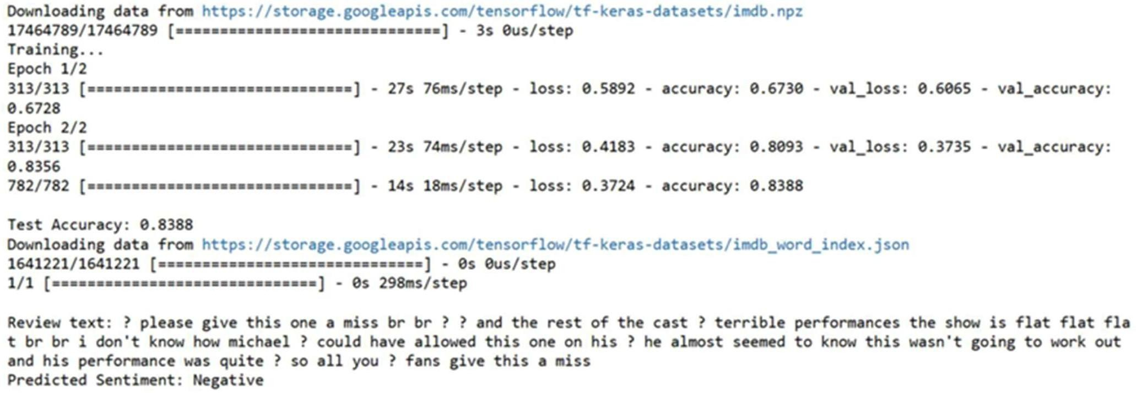

Result:

A Recurrent Neural Network (RNN) using Keras/TensorFlow for classifying the sentiment of text data (e.g., movie reviews) as positive or negative is successfully built and the output is verified.

Ex No: 7 BUILD AUTOENCODERS WITH KERAS/TENSORFLOW

Aim:
To build autoencoders with Keras/TensorFlow.

Procedure:

- Download and load the dataset.
- Perform analysis and preprocessing of the dataset.
- Build a simple neural network model using Keras/TensorFlow.
- Compile and fit the model.
- Perform prediction with the test dataset.
- Calculate performance metrics.

import numpy as np
import matplotlib.pyplot as plt
from keras.layers import Input, Dense from keras.models import Model from keras.datasets import mnist

(x_train, _), (x_test, _) = mnist.load_data() x_train = x_train.astype('float32') / 255. x_test = x_test.astype('float32') / 255.
x_train = x_train.reshape((len(x_train), np.prod(x_train.shape[1:]))) x_test = x_test.reshape((len(x_test), np.prod(x_test.shape[1:])))

input_img = Input(shape=(784,))
encoded = Dense(32, activation='relu')(input_img) decoded = Dense(784, activation='sigmoid')(encoded) autoencoder = Model(input_img, decoded)

autoencoder.compile(optimizer='adam', loss='binary_crossentropy') autoencoder.fit(x_train, x_train,
epochs=50, batch_size=256, shuffle=True,
validation_data=(x_test, x_test)) test_loss = autoencoder.evaluate(x_test, x_test) decoded_imgs = autoencoder.predict(x_test)

threshold = 0.5 correct_predictions = np.sum(
np.where(x_test >= threshold, 1, 0) ==
np.where(decoded_imgs >= threshold, 1, 0)
)

total_pixels = x_test.shape[0] * x_test.shape[1] test_accuracy = correct_predictions / total_pixels print("Test Loss:", test_loss)
print("Test Accuracy:", test_accuracy)

n = 10
plt.figure(figsize=(20, 4)) for i in range(n):
# Display original
ax = plt.subplot(2, n, i + 1) plt.imshow(x_test[i].reshape(28, 28)) plt.gray() ax.get_xaxis().set_visible(False) ax.get_yaxis().set_visible(False)

# Display reconstruction with threshold ax = plt.subplot(2, n, i + 1 + n)
reconstruction = decoded_imgs[i].reshape(28, 28) plt.imshow(np.where(reconstruction >= threshold, 1.0, 0.0)) plt.gray()
ax.get_xaxis().set_visible(False) ax.get_yaxis().set_visible(False)
plt.show()

Output:
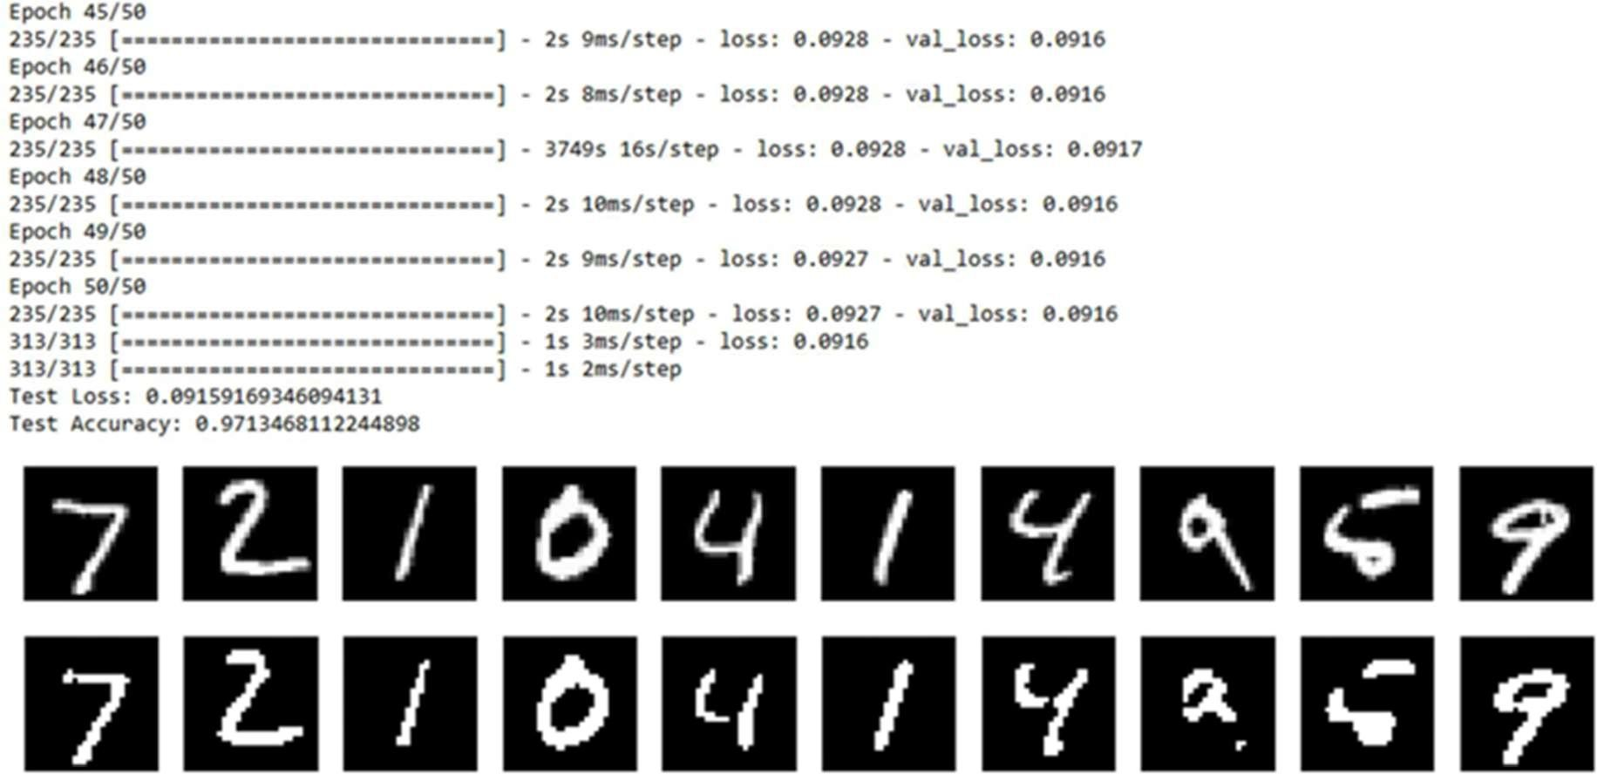

Result:

A hautoencoders with Keras/TensorFlow is successfully built and the output is verified.

Ex No: 8 OBJECT DETECTION WITH YOLO3

Aim:
To build an object detection model with YOLO3 using Keras/TensorFlow.

Procedure:

- Download and load the dataset.
- Perform analysis and preprocessing of the dataset.
- Build a simple neural network model using Keras/TensorFlow.
- Compile and fit the model.
- Perform prediction with the test dataset.
- Calculate performance metrics.

import cv2
import matplotlib.pyplot as plt import numpy as np

# Define the paths to the YOLOv3 configuration, weights, and class names files cfg_file = '/content/yolov3.cfg'
weight_file = '/content/yolov3.weights' namesfile = '/content/coco.names'

# Load the YOLOv3 model
net = cv2.dnn.readNet(weight_file, cfg_file)

# Load class names
with open(namesfile, 'r') as f: classes = f.read().strip().split('\n')

# Load an image for object detection image_path = '/content/hit.jpg' image = cv2.imread(image_path)

# Get the height and width of the image height, width = image.shape[:2]

# Create a blob from the image
blob = cv2.dnn.blobFromImage(image, 1/255.0, (416, 416), swapRB=True, crop=False) net.setInput(blob)

# Get the names of the output layers
layer_names = net.getUnconnectedOutLayersNames()

# Run forward pass

outs = net.forward(layer_names)

# Initialize lists to store detected objects' information class_ids = []
confidences= [] boxes = []

# Define a confidence threshold for object detection conf_threshold = 0.5

# Loop over the detections for out in outs:
for detection in out:
scores = detection[5:] class_id = np.argmax(scores) confidence = scores[class_id]
if confidence > conf_threshold: # Object detected
center_x = int(detection[0] * width) center_y = int(detection[1] * height) w = int(detection[2] * width)
h = int(detection[3] * height)

# Rectangle coordinates x = int(center_x - w / 2) y = int(center_y - h / 2)

class_ids.append(class_id) confidences.append(float(confidence)) boxes.append([x, y, w, h])

# Apply non-maximum suppression to eliminate overlapping boxes nms_threshold = 0.4
indices = cv2.dnn.NMSBoxes(boxes, confidences, conf_threshold, nms_threshold)

# Draw bounding boxes and labels on the image for i in indices.flatten(): # flatten for compatibility
x, y, w, h = boxes[i]
label = str(classes[class_ids[i]]) confidence = confidences[i]

cv2.rectangle(image, (x, y), (x + w, y + h), (0, 255, 0), 2)
cv2.putText(image, f'{label} {confidence:.2f}', (x, y - 10), cv2.FONT_HERSHEY_SIMPLEX, 0.8, (0, 255, 0), 2)

# Display the result in Jupyter Notebook plt.figure(figsize=(10, 8)) plt.imshow(cv2.cvtColor(image, cv2.COLOR_BGR2RGB)) plt.axis('off')
plt.show()

Output:

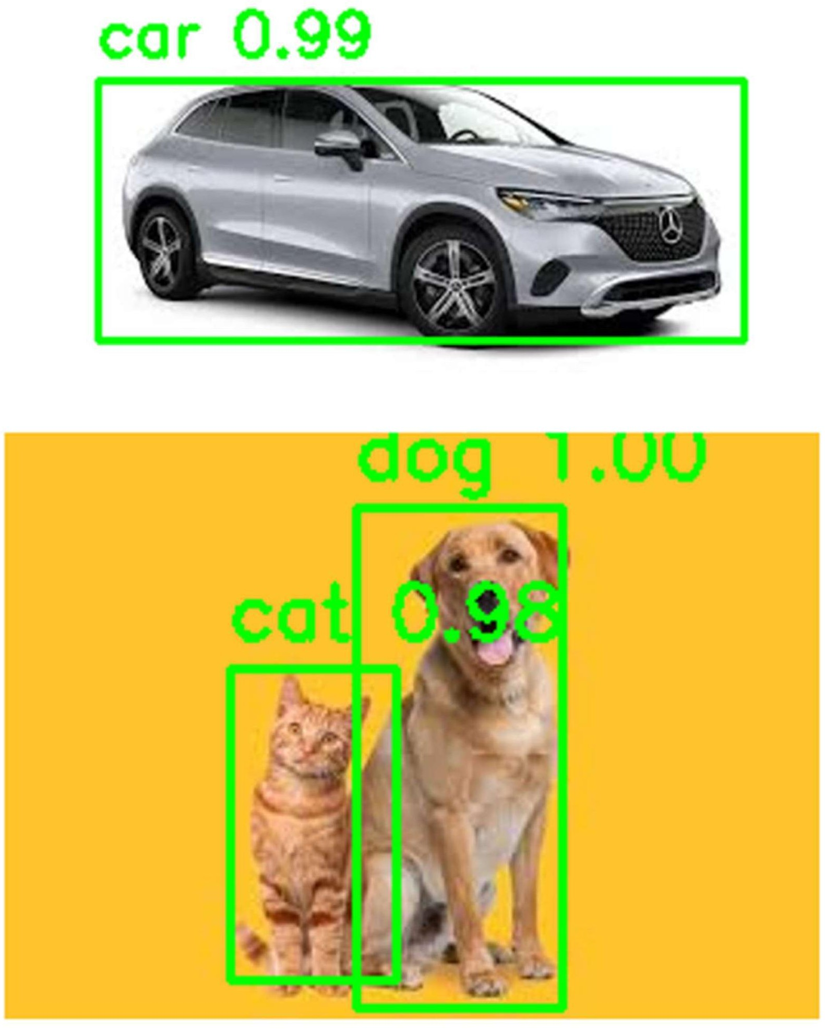

Result:

An object detection model with YOLO3 using Keras/TensorFlow is successfully built and the output is verified.

Ex No: 9 BUILD GENERATIVE ADVERSARIAL NEURAL NETWORK

Aim:
To build a generative adversarial neural network using Keras/TensorFlow.

Procedure:

- Download and load the dataset.
- Perform analysis and preprocessing of the dataset.
- Build a simple neural network model using Keras/TensorFlow.
- Compile and fit the model.
- Perform prediction with the test dataset.
- Calculate performance metrics.

import numpy as np import tensorflow as tf
from tensorflow.keras.layers import Dense
from tensorflow.keras.models import Sequential from tensorflow.keras.optimizers import Adam from sklearn.datasets import load_iris
import matplotlib.pyplot as plt

# Load and Preprocess the Iris Dataset iris = load_iris()
x_train = iris.data

# Build the GAN model def build_generator():
model = Sequential()
model.add(Dense(128, input_shape=(100,), activation='relu')) model.add(Dense(4, activation='linear')) # Output 4 features return model

def build_discriminator():
model = Sequential()
model.add(Dense(128, input_shape=(4,), activation='relu')) model.add(Dense(1, activation='sigmoid'))
return model

def build_gan(generator, discriminator): discriminator.trainable = False model = Sequential() model.add(generator) model.add(discriminator)
return model

generator = build_generator() discriminator = build_discriminator()
gan = build_gan(generator, discriminator)

# Compile the Models
generator.compile(loss='mean_squared_error', optimizer=Adam(0.0002, 0.5))
discriminator.compile(loss='binary_crossentropy', optimizer=Adam(0.0002, 0.5), metrics=['accuracy'])
gan.compile(loss='binary_crossentropy', optimizer=Adam(0.0002, 0.5))

# Training Loop epochs = 200
batch_size = 16

for epoch in range(epochs):
# Train discriminator
idx = np.random.randint(0, x_train.shape[0], batch_size) real_samples = x_train[idx]
fake_samples = generator.predict(np.random.normal(0, 1, (batch_size, 100)), verbose=0)

real_labels = np.ones((batch_size, 1)) fake_labels = np.zeros((batch_size, 1))

d_loss_real = discriminator.train_on_batch(real_samples, real_labels) d_loss_fake = discriminator.train_on_batch(fake_samples, fake_labels)

# Train generator
noise = np.random.normal(0, 1, (batch_size, 100)) g_loss = gan.train_on_batch(noise, real_labels)

# Print progress
print(f"Epoch {epoch}/{epochs} | Discriminator Loss: {0.5 * (d_loss_real[0] + d_loss_fake[0])} | Generator Loss: {g_loss}")

# Generating Synthetic Data
synthetic_data = generator.predict(np.random.normal(0, 1, (150, 100)), verbose=0)

# Create scatter plots for feature pairs plt.figure(figsize=(12, 8))
plot_idx = 1

for i in range(4):
for j in range(i + 1, 4):
plt.subplot(2, 3, plot_idx)
plt.scatter(x_train[:, i], x_train[:, j], label='Real Data', c='blue', marker='o', s=30) plt.scatter(synthetic_data[:, i], synthetic_data[:, j], label='Synthetic Data', c='red', marker='x',
s=30)
plt.xlabel(f'Feature {i + 1}') plt.ylabel(f'Feature {j + 1}') plt.legend()
plot_idx += 1

plt.tight_layout() plt.show()

Output:
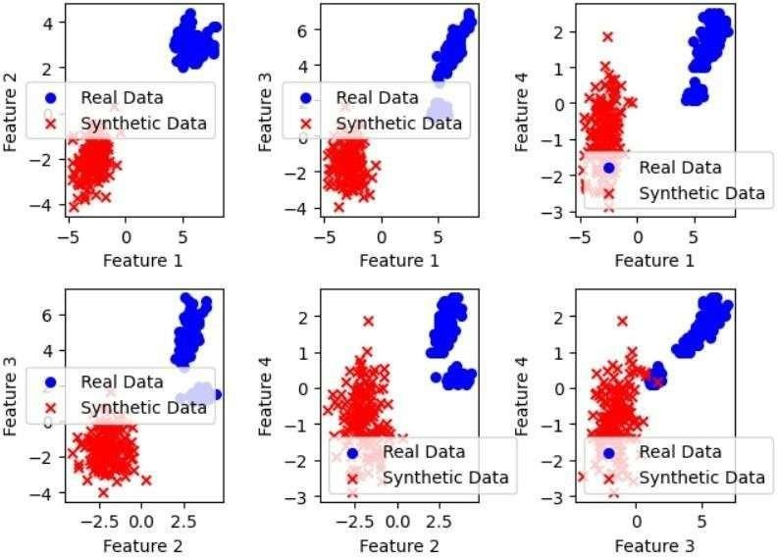
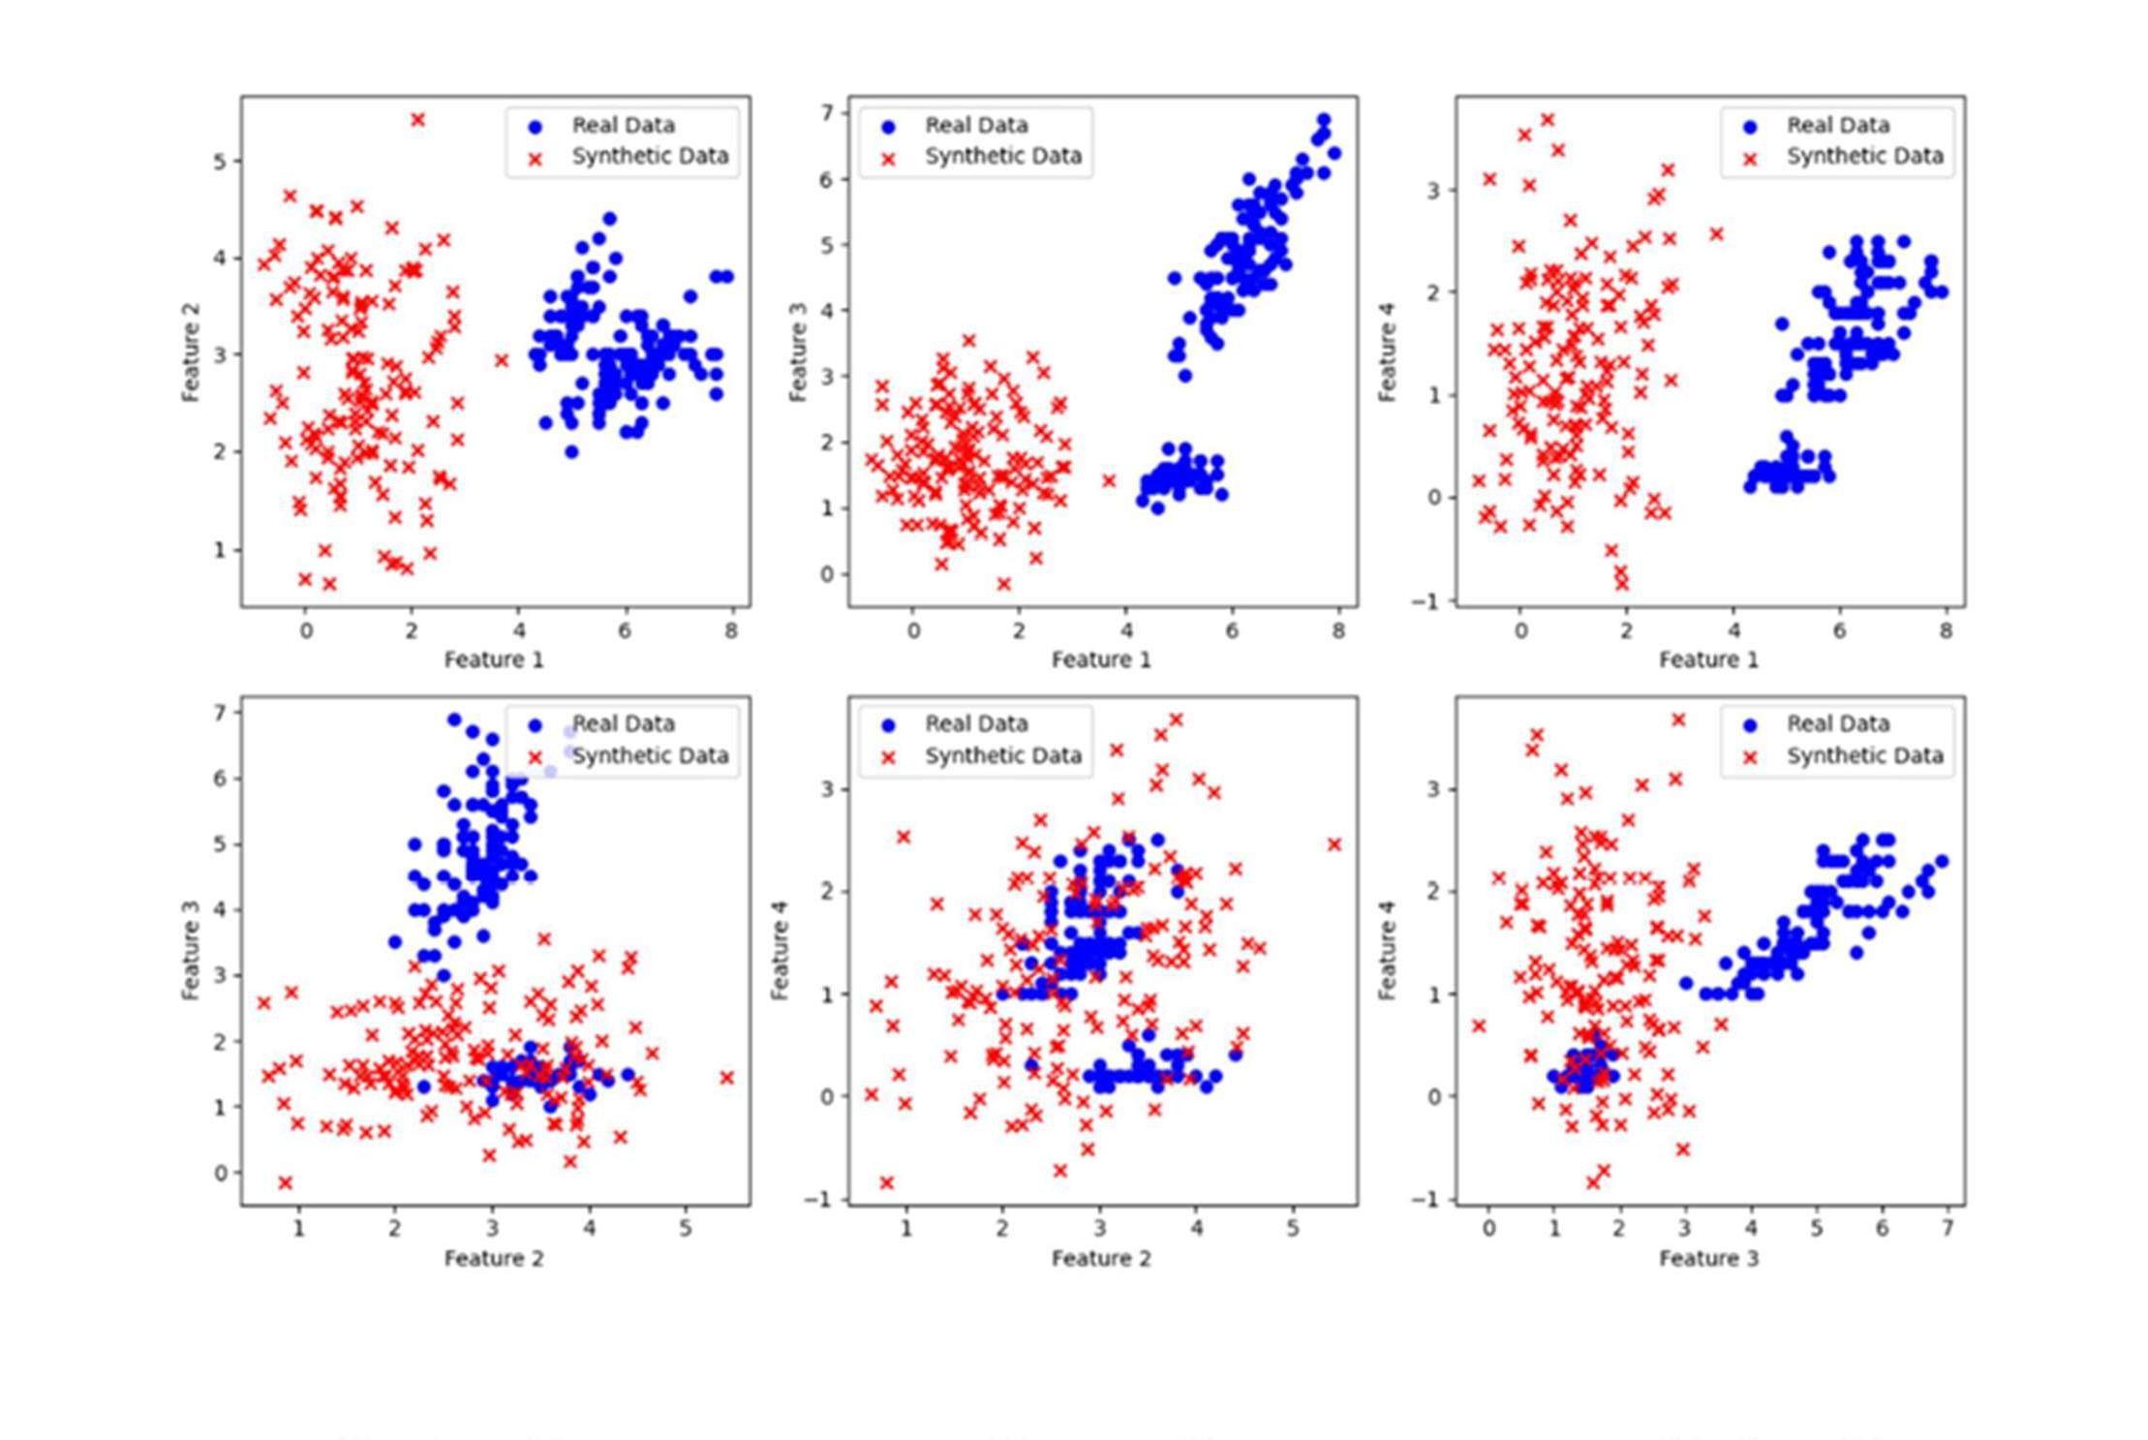

Result:

A generative adversarial neural network using Keras/TensorFlow is successfully built and the output is verified.

Ex No: 10 MINI PROJECT – CNN OR RNN BASED APPLICATION

Aim:
To develop an application that is based on convolutional neural network or recurrent neural network in Keras/TensorFlow.

Code:
from ultralytics import YOLO import cv2
import math
import numpy as np import time

# Load YOLO model
model = YOLO('yolov8n.pt')

# Video path
video_path = 'Overtake.mp4'
cap = cv2.VideoCapture(video_path)

# Configuration thresholds
CENTER_X_MARGIN = 0.20 # Vehicles within ±20% of center X considered front vehicles MIN_Y_RATIO = 0.5 # Consider boxes with center Y > 50% of frame height CLOSE_DIST_RATIO = 0.30 # Distance < 30% of frame height -> unsafe APPROACH_SPEED_PIX = 8.0 # Pixels per frame considered fast approach APPROACH_DIST_RATIO = 0.45 # Distance < 45% of frame height + fast approach -> unsafe

# Tracking initialization
prev_centroids = [] # List of (cx, cy) prev_ids = [] # Corresponding IDs
next_id = 0 # Synthetic ID generator
max_match_dist = 80 # Max distance for matching centroids between frames font = cv2.FONT_HERSHEY_SIMPLEX

# Helper function for centroid matching def match_centroids(prev, curr, prev_ids):
global next_id mapping = {} used_prev = set()

for i, c in enumerate(curr): best_j, best_d = None, 1e9 for j, p in enumerate(prev):
if j in used_prev: continue
d = math.hypot(c[0] - p[0], c[1] - p[1]) if d < best_d:
best_d = d

best_j = j

if best_j is not None and best_d < max_match_dist: mapping[i] = prev_ids[best_j] used_prev.add(best_j)
else:
mapping[i] = next_id next_id += 1

return mapping

# Main processing loop last_time = time.time()

while True:
ret, frame = cap.read() if not ret:
break

frame_h, frame_w = frame.shape[:2] center_x = frame_w // 2

results = model(frame)
boxes = results[0].boxes.xyxy.cpu().numpy() if hasattr(results[0].boxes, "xyxy") else np.array([])

detected = [] for b in boxes:
x1, y1, x2, y2 = b[:4]
cx, cy = (x1 + x2) / 2, (y1 + y2) / 2
detected.append({'box': (int(x1), int(y1), int(x2), int(y2)), 'cx': cx, 'cy': cy})

# Prepare centroid lists
curr_centroids = [(d['cx'], d['cy']) for d in detected]

# Match with previous centroids for stable ID assignment if prev_centroids:
mapping = match_centroids(prev_centroids, curr_centroids, prev_ids) else:
mapping = {i: i for i in range(len(curr_centroids))} next_id = len(curr_centroids)
curr_ids = [mapping[i] for i in range(len(curr_centroids))] # Build a dict for current frame IDs
curr_dict = {}
for i, d in enumerate(detected): cid = curr_ids[i]
x1, y1, x2, y2 = d['box'] cx, cy = d['cx'], d['cy'] bbox_h = y2 - y1

curr_dict[cid] = {'box': d['box'], 'cx': cx, 'cy': cy, 'bbox_h': bbox_h}

# Distance and approach checks approach_flag = False unsafe_flag = False
front_id = None front_min_dist = float('inf')

# Find "front" vehicle near bottom-center for cid, info in curr_dict.items():
cx, cy = info['cx'], info['cy']
if cy > frame_h * MIN_Y_RATIO and abs(cx - center_x) < frame_w * CENTER_X_MARGIN: dist_to_bottom = frame_h - cy
if dist_to_bottom < front_min_dist: front_min_dist = dist_to_bottom front_id = cid

# If a front vehicle is identified, check safety if front_id is not None:
if front_min_dist < frame_h * CLOSE_DIST_RATIO: unsafe_flag = True

if prev_centroids and front_id in prev_ids: idx_prev = prev_ids.index(front_id) prev_cx, prev_cy = prev_centroids[idx_prev] prev_dist = frame_h - prev_cy
curr_cx = curr_dict[front_id]['cx'] curr_cy = curr_dict[front_id]['cy'] curr_dist = frame_h - curr_cy approach_speed = prev_dist - curr_dist

if approach_speed > APPROACH_SPEED_PIX and curr_dist < frame_h * APPROACH_DIST_RATIO:
approach_flag = True unsafe_flag = True

# Draw bounding boxes
for cid, info in curr_dict.items(): x1, y1, x2, y2 = info['box']
if cid == front_id:
color = (0, 0, 255) if unsafe_flag else (0, 255, 0) else:
color = (200, 200, 200)
cv2.rectangle(frame, (x1, y1), (x2, y2), color, 2) cv2.putText(frame, f"ID:{cid}", (x1, y1 - 6), font, 0.5, color, 1)

# Display status
status = "SAFE" if not unsafe_flag else "UNSAFE" status_color = (0, 255, 0) if not unsafe_flag else (0, 0, 255)
cv2.putText(frame, f"{status} ALERT", (30, 40), font, 1.1, status_color, 3)

if front_id is not None:
cv2.putText(frame, f"FrontID:{front_id} dist_px:{int(front_min_dist)}", (30, 80), font, 0.7, (255, 255, 0), 2)

if prev_centroids and front_id in prev_ids: idx_prev = prev_ids.index(front_id) prev_cx, prev_cy = prev_centroids[idx_prev] prev_dist = int(frame_h - prev_cy)
curr_dist = int(frame_h - curr_dict[front_id]['cy']) approach_speed = prev_dist - curr_dist
cv2.putText(frame, f"approach_px/frame: {int(approach_speed)}", (30, 110), font, 0.6, (255, 200, 0), 1)

# Show frame
cv2.imshow("Improved Unsafe Detection", frame) if cv2.waitKey(120) & 0xFF == ord('q'):
break

# Update previous frame data prev_centroids = curr_centroids prev_ids = curr_ids

cap.release() cv2.destroyAllWindows()
OUTPUT:
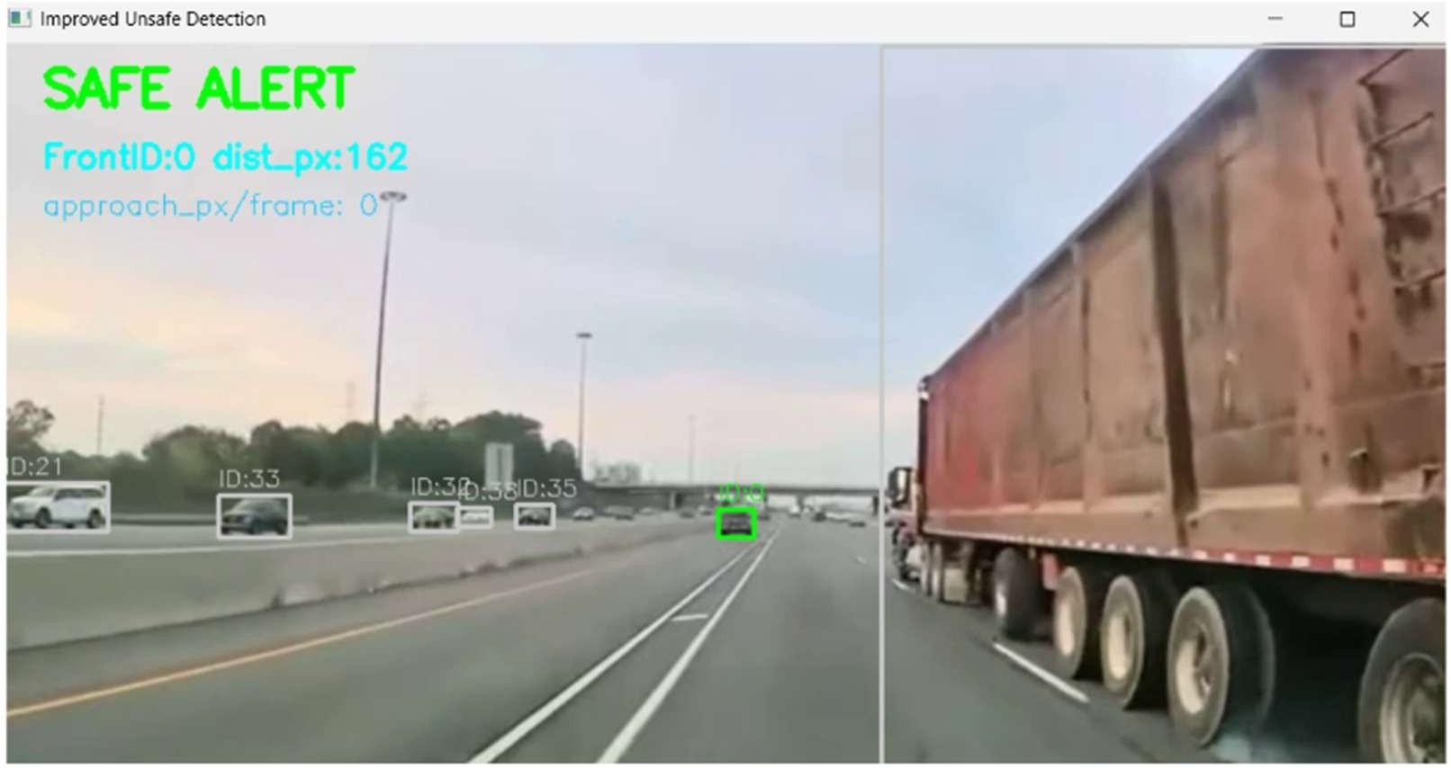

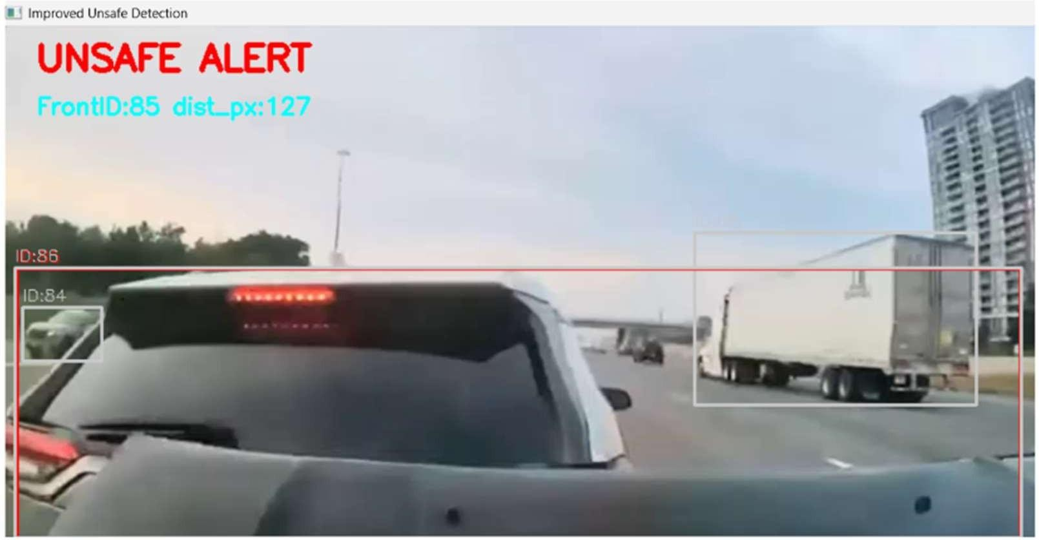

RESULT:
The implemented deep learning model using pretrained VGG16 successfully extracted features from signatures and classified them as genuine or forged. The system achieved high accuracy on the test dataset, effectively distinguishing between authentic and forged signatures in real time.

